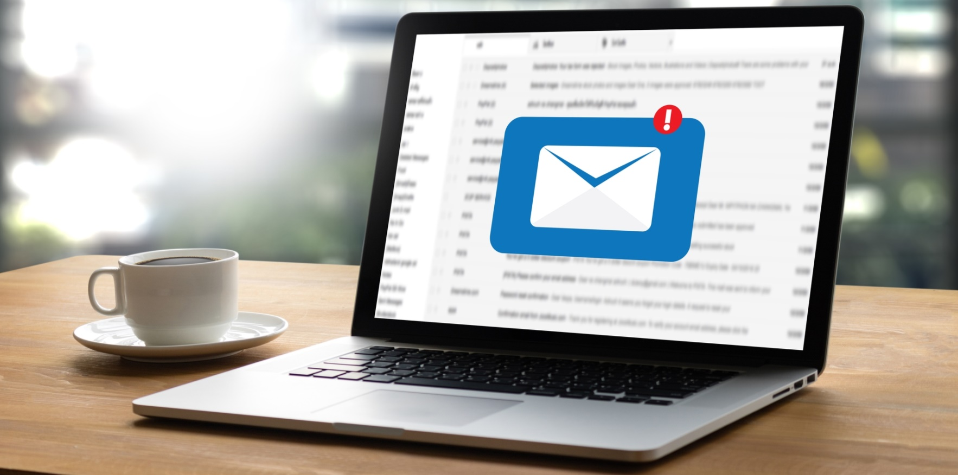
Keep Your Retirement Account Secure with Email Validation
The security of your retirement plan and personal information is a top priority for us. To mitigate fraud and cyber security issues to your retirement plan account, we encourage you to ensure BPAS has a current, valid email address on record. Including your email address in your online account will help BPAS safeguard your account by notifying you immediately when there is activity on your account. BPAS will never use your email address for spam-related activity.
BPAS will notify you by email anytime you:
- log in from a new device
- reset your password
- have activity on your account (email change, transactions, etc.)
It’s the fastest, most secure way for you to prevent fraudulent activity on your account.
Adding your email address to your retirement account is easy!
- Log in to your account at https://www.bpas.com/participants:
  - Select Retirement Account from the drop-down menu; click Login
  - On the Participant Education Center page, click Login to Your Account
  - Enter your User Name and Password; click Login
- Select Account Maintenance, then Change Personal Data
- Enter your preferred email address and save your changes
While you’re at it, consider selecting the GoGreen option. With GoGreen, you can opt out of receiving paper confirms, regulatory notices, and quarterly statements. You’ll find the GoGreen options in the Account Maintenance tab.
Have questions? Contact BPAS Customer Service at 1-866-401-5272, Monday – Friday, 8:00 am – 8:00 pm ET or send a secure message from BPAS.com/participants/customer-service.

